CST8503 Assignment 1 Family Tree

Overview
This assignment introduces Prolog concepts using a family tree example. Your assignment is to implement the Family Tree example described in this document, and complete the exercises below. This is an individual assignment.

When you have finished this assignment, you will have the ability to use the following Prolog concepts in your Prolog programs:
- Clause, fact, rule, question
- The head of a clause, the body of a clause
- Recursive rule, recursive definition
- Procedure
- Atom, variable
- Instantiation of a variable
- Goal
- Goal is satisfiable, goal succeeds
- Goal is unsatisfiable, goal fails
- Backtracking
- Declarative meaning, procedural meaning

Family Tree Assignment

Implement the family diagram below in a Prolog program file so that you can demonstrate it running to your lab instructor. You will define the parent/2 relation where parent(x,y) means x is the parent of y. Each arrow in the diagram represents an instance of the parent relationship. Remember that capital letters represent variables in Prolog, so at this stage, you will have no capital letters in your program.

Remember to include your declarative comment header above each predicate definition.

When you are finished, you will have a Prolog text file that starts with the comment header, followed by lines of parent/2 Prolog code (one line for each arrow in the diagram).
You will add code to this file as you work on this assignment.

henry
julie

susan
joe

josh
jeff

brad

For the following exercises, when asked to write Prolog code, add the additional code to your Prolog program file and additionally copy/paste the additional code into this document as your answer under the corresponding question. When asked to formulate a Prolog question/query, answer in-place in this document. When asked to draw a diagram/picture, it is acceptable to draw in this document with MS Word or draw on paper and take a picture with your phone or laptop to include the image file in this document.

  - What will be Prolog's answers to the following Prolog queries? (0.5 mark each)
- ?- parent(brad, X).
- ?- parent(X, brad).
- ?- parent(henry, X), parent(X, jeff).
- ?- parent(henry, X), parent(X, Y), parent(Y, brad).

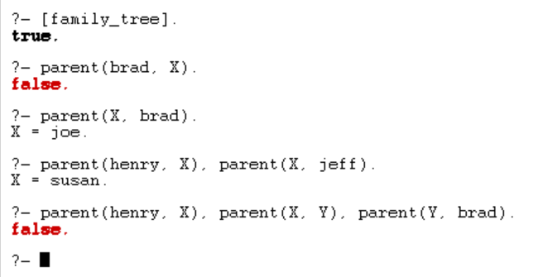

  - Provide Prolog queries that correspond to the following questions about the parent relation: (0.5 mark each)
    - Who is brad's parent?
    - Does josh have a child?
    - Who is brad's grandparent? (You need to limit the query to uses of the parent relation.)

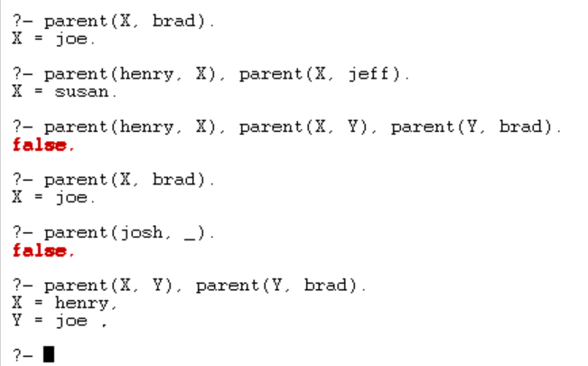

  - Translate the following statements into Prolog rules and add the resulting Prolog code to your program (0.5 mark each)
    - Everybody who has a child is educated (introduce a one-argument relation educated).
    - For all X, if X has a child who has a sibling, then X is poor (introduce a new relation poor, and assume sibling(X,Y) is already defined to mean X and Y are siblings. ).

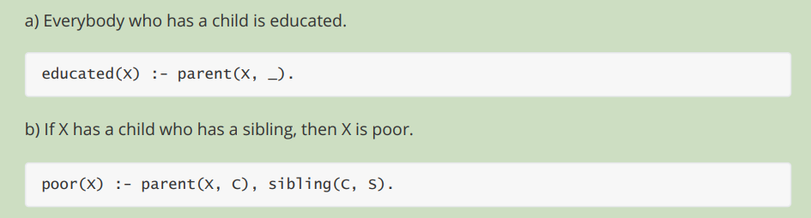

  - Define the relation grandchild using the parent relation. Hint: It will be similar to the grandparent relation below. Add the code for both grandparent and grandchild to your Prolog program. (0.5 mark)
grandparent(X,Z):-
parent(X,Y),
parent(Y,Z).

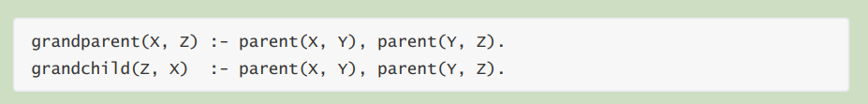

  - For each person named in our program, use male/1 and female/1 to assert that they are male or female. Then define a sister(X,Y) relation in terms of parent and female (X is the sister of Y if Z is parent of X, and Z is parent of Y, and X is female, and X is not the same as Y. There is a built-in predicate you can use, dif(X,Y) that means X is not the same as Y. Define the relation aunt(X,Y) in terms of the relations parent and sister. Add the prolog code to your program. (1 mark)

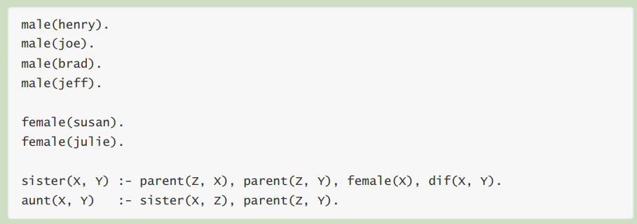

  - Consider the following two alternative definitions of the ancestor relation:

ancestor(X, Z):-
parent(X,Z).
ancestor(X,Z):-
parent(X,Y),
ancestor(Y,Z).
ancestor(X, Z):-
parent(X,Z).
ancestor(X,Z):-
parent(Y,Z),
ancestor(X,Y).

Do these both seem to be a proper definition of ancestor?

Draw two diagrams that show X, Y, and Z, and the parent relationships, with vertical dots to indicate an indefinite number of intermediate individuals. Use arrows to indicate and label the parent and ancestor relationships. The first diagram is started for you – it shows that X and Y are directly related with no intermediate individual (what’s the relationship?). It also shows that Y and Z are indirectly related, with some indefinite number of individuals between them (what’s the relationship?). You need to add the labeled arrows to the first diagram, and completely draw the second diagram. (1 mark)
X
Y
.
.
.
.
.
Z

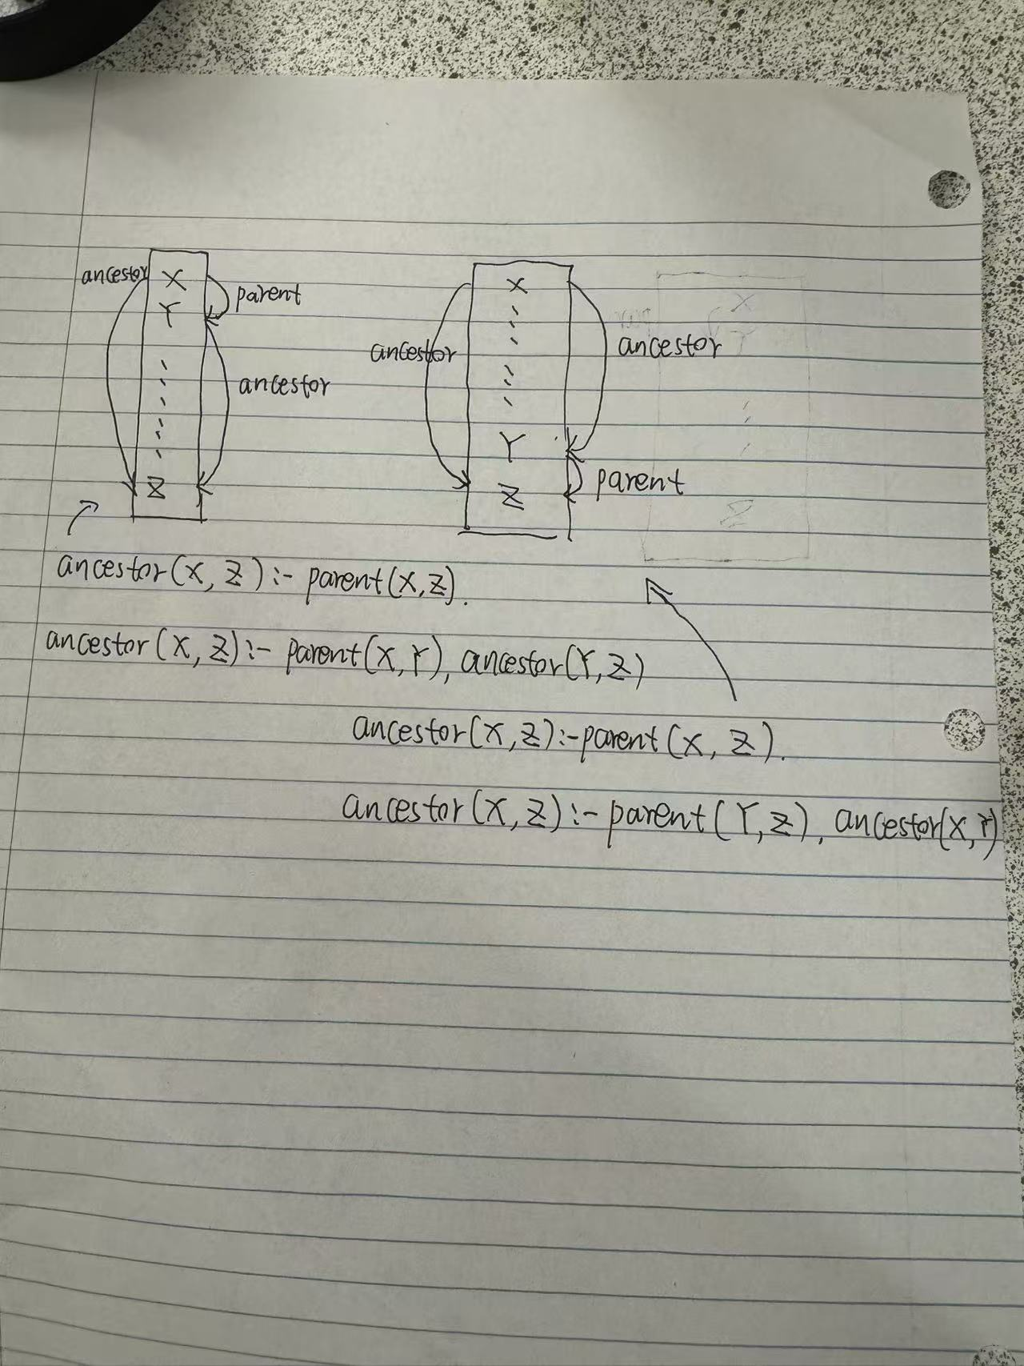

  - Try to understand how Prolog derives answers to the following queries, using your Prolog code from this assignment. Open your Prolog program file in a window so that you can view your program and this question at the same time. Trace through, in your mind, what the Prolog algorithm will do with your program when the following queries are issued. Show your work similar to the example, showing the intermediate goals indented, and draw an X where Prolog will backtrack to the most recent choice point. (3 marks)

Example
?- grandparent(julie,henry).
parent(julie,Y).
parent(julie,joe).
parent(joe,henry).
X backtrack
parent(julie,Y).
parent(julie,susan).
parent(susan,henry).
X backtrack
X no more alternatives, fail.

- ?- parent(henry, joe).
- ?- grandparent(henry, josh).
- ?- grandparent(joe, brad).

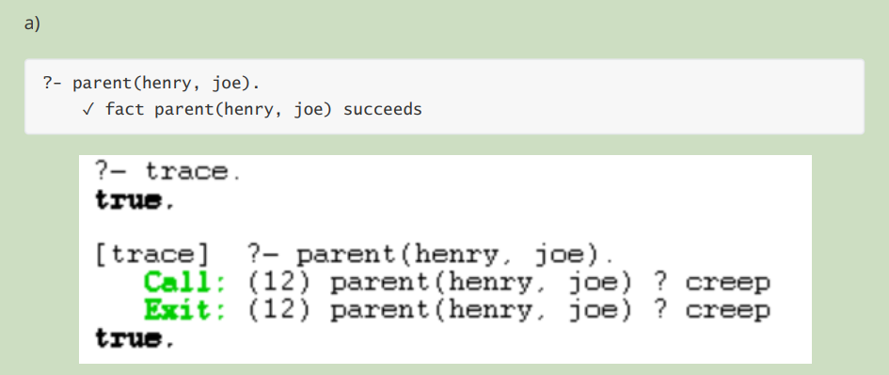

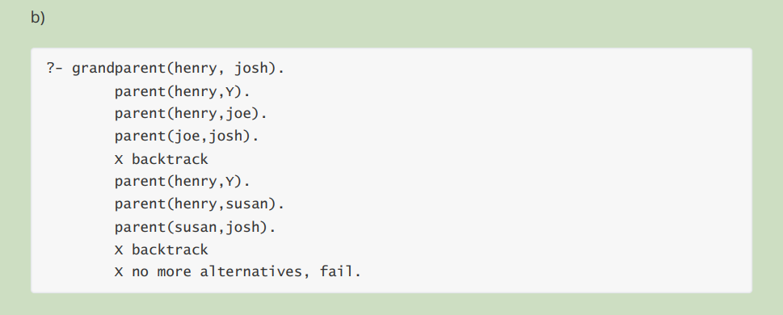
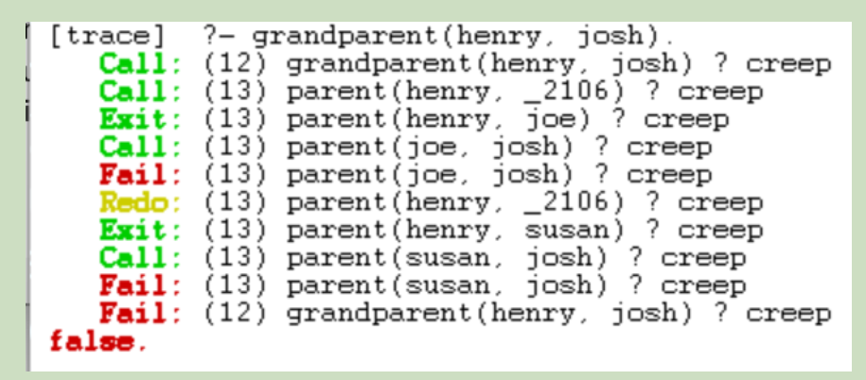

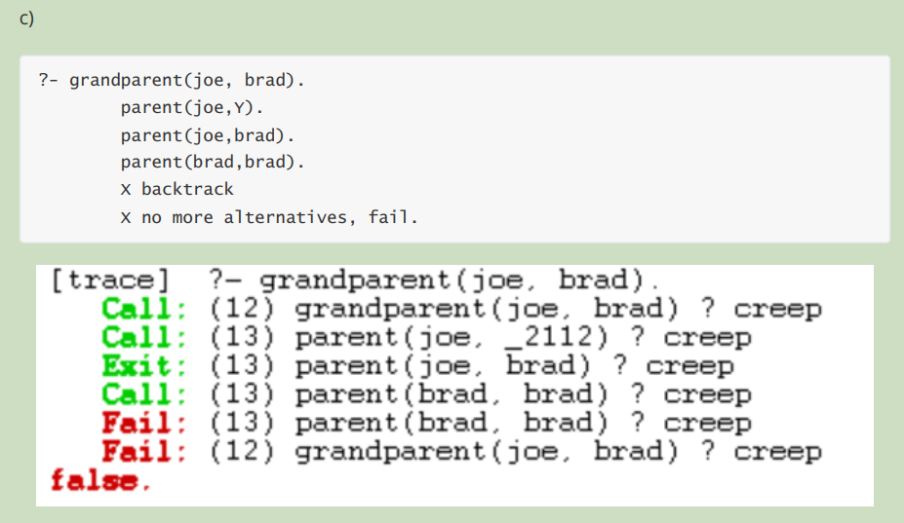

That’s the end of the assignment!

Submission

Submit to Brightspace your Prolog code file as well as this document with your answers in it. You will not be able to submit a file with a .pl extension, but you can either rename .pl to a .txt extension, or alternatively submit a zip file containing the two files.

Demonstration

Run your program for you lab instructor, and be prepared to ask questions about your solution.

